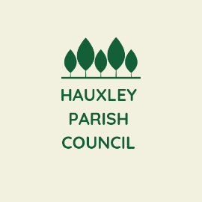 Hauxley Parish Council
c/o 14 Oswald Street,
Amble,
Northumberland NE65 0EG
Telephone: 07786255649

Parish Clerk: Mrs Jade Reynolds
email: hauxleypc@gmail.com
website: https://northumberlandparishes.uk/hauxley

To Members of Hauxley Parish Council; Cllrs Robinson, Callender, Nichol, Appleby and Busby

You are summoned to the Ordinary meeting of the Parish Council to be held on Thursday 8 June at 6.30pm at Hauxley Village Hall for the transaction of the business shown on the agenda below.

BUSINESS TO BE TRANSACTED

14/23 To receive apologies for absence

15/23 To receive any declarations of interest from Members
Members are invited to declare disclosable pecuniary interests and other interests in items on the agenda as required by the Hauxley Council Code of Conduct for Members and by the Localism Act 2011.

16/23 Internal Audit report for year 2022/23
- To receive the report
- To agree to the recommendations within the report
- To organise/find an internal auditor for 2023/24
17/23 Annual Governance and Accountability Return 2022/23
- To approve the Annual Governance Statement
- To approve the accounting statements
- To confirm and approve the Certificate of Exemption 2022/23
- To note the exercise of Public Rights to Inspect 2022/23

18/23 Date of Next Meeting
Monday 10th July

